Assignment 9.4

Transfer streaming data from your local file system to HDFS using flume spool directory.

creation of a folder spool with 2 files say sample1 and sample2

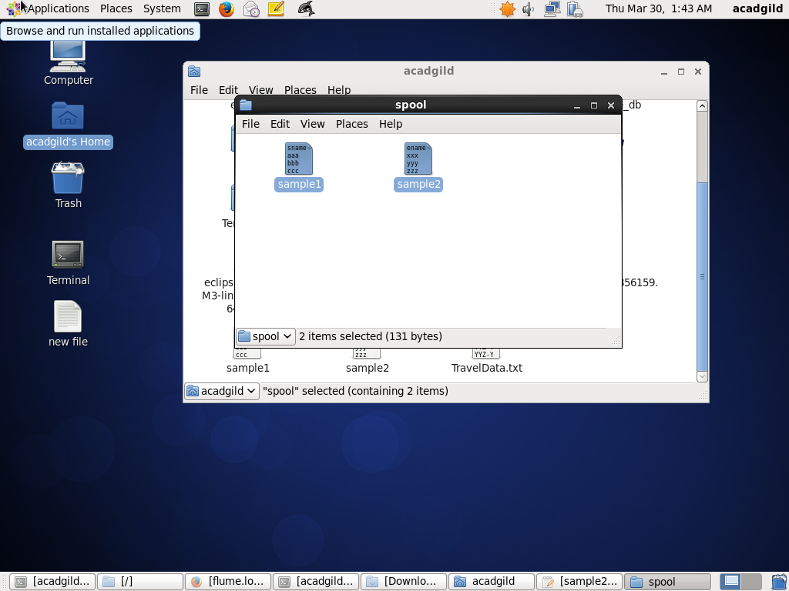

moving the configuration file into conf folder of flume

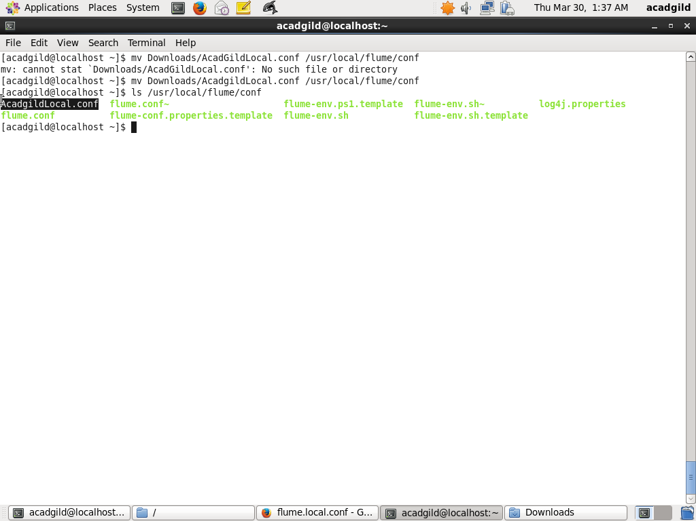

creation of the output directory

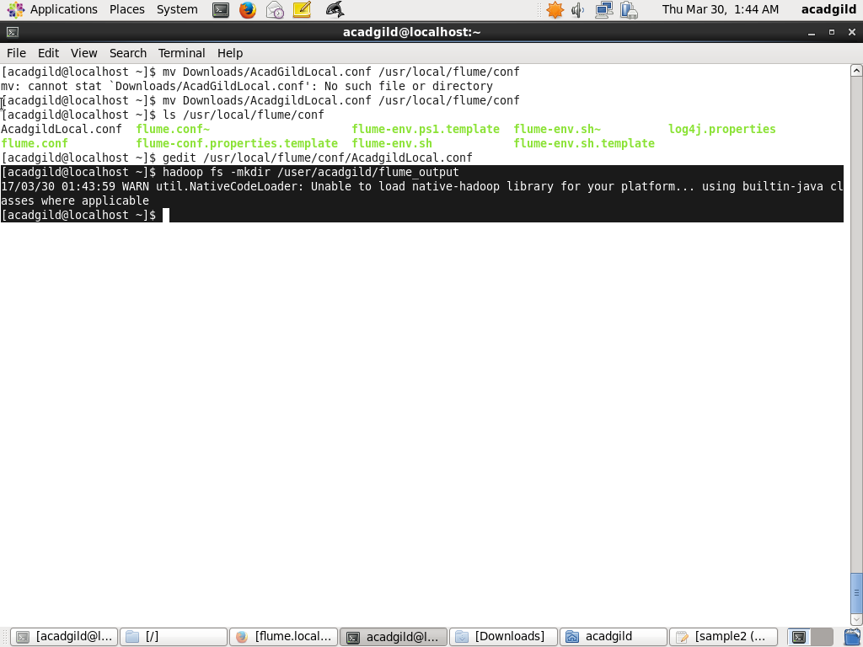

modification of .conf file according to my path

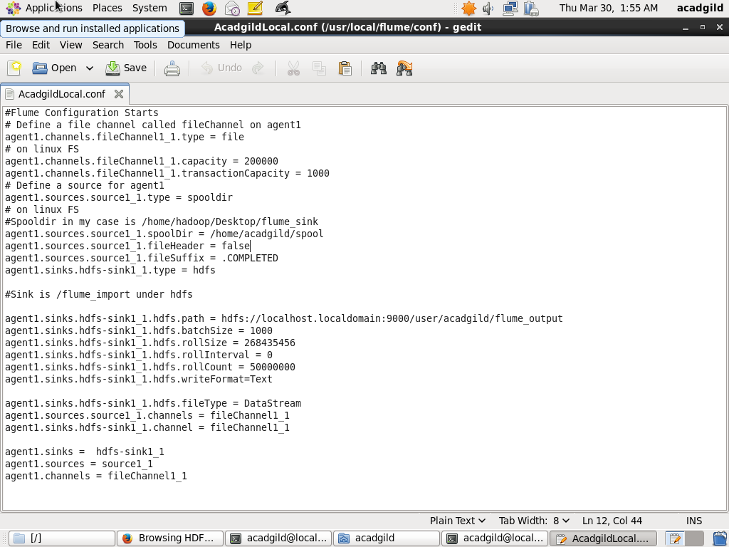

running the flume agent

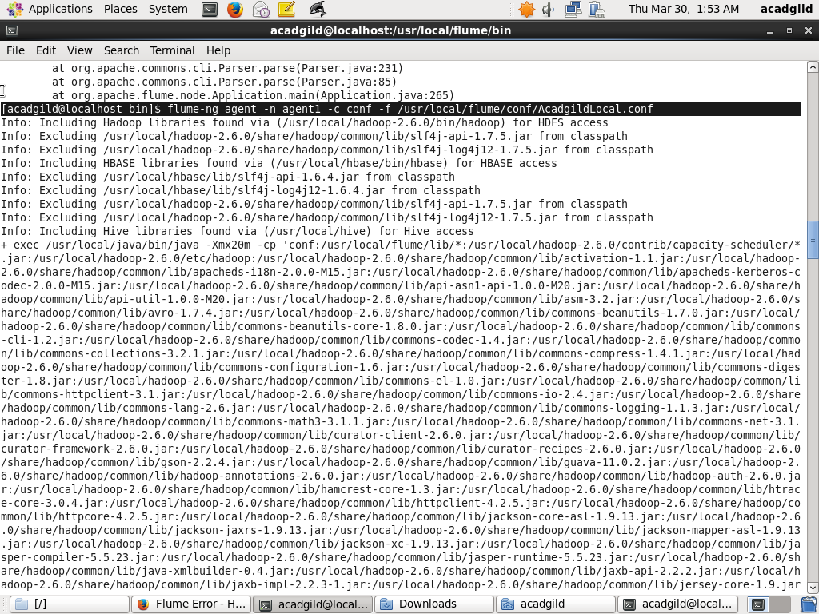

result

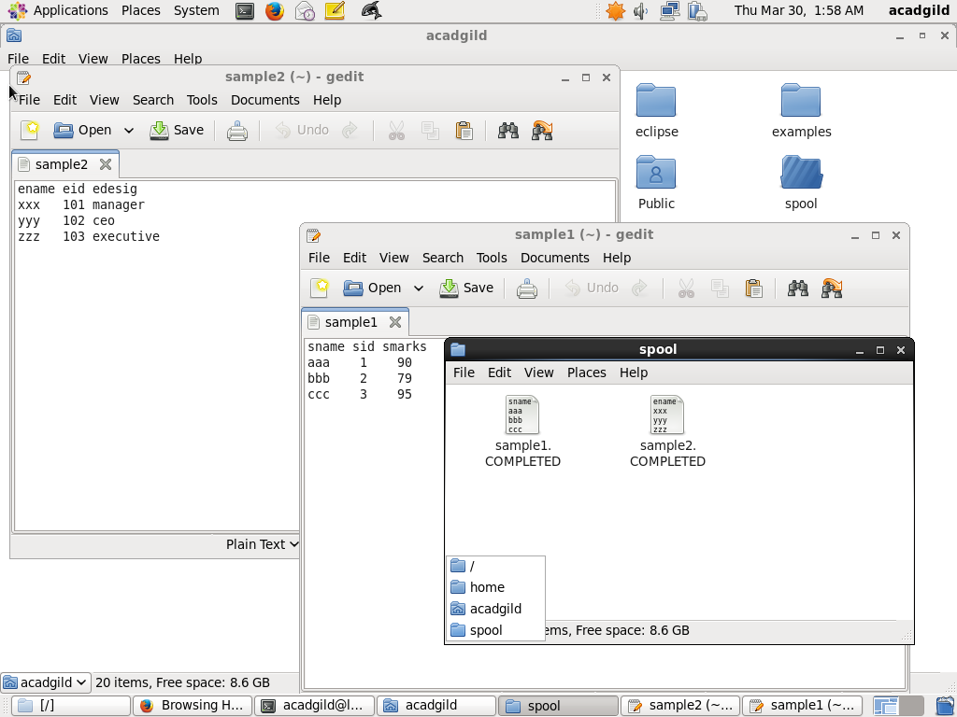

output stored on hdfs

